Multiple-choice section

Question 1 [3.1]

If Louise ate of the lollies shown here, how many did she eat?

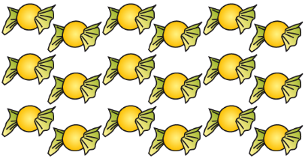

A 4 B 8 C 9 D 12

Question 2 [3.1]

Which of the following improper fractions are equivalent to the whole number -7?

A  B  C  D 

Question 3 [3.1]

The fraction of this square that is shaded is:

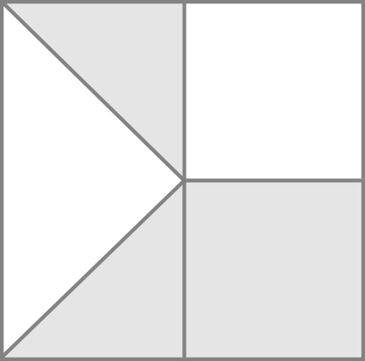

A  B  C  D 

Question 4 [3.2]

Which of the following fractions is the simplest form of ?

A  B  C  D 

Question 5 [3.3]

Which of the following is closest to ?

A  B  C  D 

Question 6 [3.4]



A  B  C  D 

Question 7 [3.4]

Which whole number is closest to the sum of and ?

A 1 B 2 C 12 D 23

Question 8 [3.5]

 of $240 =

A $20 B $40 C $180 D $200

Question 9 [3.6]



A  B  C  D 6

Question 10 [3.7]

Nicky shared a punnet of strawberries with his dad:   
 for dad and  for Nicky

If his dad ate all of the 10 strawberries he was given, how many strawberries were in the original punnet?

A 15 B 20 C 25 D 30

Multiple-choice total marks: ____ / 10

Short answer section

Question 11 2 marks [3.1, 3.2]

Use words from the list below to complete the following sentences.

*improper fractions  simplify  unit fractions  proper fractions  add  divide*

(a) You __________ fractions by cancelling common factors in the numerator and denominator.

(b) _____________ have a value greater than or equal to 1.

Question 12 2 marks [3.3]

Explain what is meant by the term ‘lowest common denominator’. Use an example to help you explain.

Question 13 2 marks [3.2]

Write two fractions that simplify to .

Question 14 5 marks [3.4]

Here is Alex’s working for the fraction calculation . Alex has made an error.

(a) Circle the line of working where the error appears.

(b) Write the correct working for the question in the space next to Alex’s working.

Alex’s working Correct working



(c) Briefly explain Alex’s mistake.

Question 15 1 mark [3.1]

Write a fraction or mixed number to show the amount that each student receives if 8 pizzas are shared equally between 5 students.

Question 16 3 marks [3.2]

Find equivalent fractions by completing the following.

(a)  (b)  (c) 

Question 17 6 marks [3.3]

Write a <, > or = symbol between each of the following pairs of fractions to make a true statement. Underneath each pair, write a brief reason or calculation to justify your answer.

(a)  (b)  (c) 

Question 18 9 marks [3.4]

Calculate the following. Write your answers in simplest form and as mixed numbers, if possible.

(a)  (b) +  (c) 7 – 

Question 19 6 marks [3.5]

Calculate the following. Write your answers in simplest form and as mixed numbers, if appropriate.

(a)  of $55 (b)  (c) 

Question 20 9 marks [3.6]

Calculate the following. Write your answers in simplest form and as mixed numbers, if appropriate.

(a)  ÷  (b)  (c)  ÷ 14

Question 21 7 marks [3.7]

Simplify the following by using the correct order of operations. Write your answers in simplest form and as mixed numbers, if appropriate.

(a)  (b) 

Short answer total:_______ / 52

Extended answer section

Question 22 9 marks [3.1, 3.2, 3.3]

(a) Draw a number line from -1 to 2 and divide the number line into fractions. Use arrows to indicate the position of the following fractions or mixed numbers on the number line.  
 , , , , 

(b) Write the mixed numbers in the list in (a) as improper fractions.

(c) Which of the fractions you have placed on the number line would be closest to ?

(d) Place this list of fractions in ascending order (from smallest to largest). You could use the number line above to help you compare the sizes of fractions in the list.  


(e) Imagine you could extend the number line in (a) further to the right. How many whole numbers would there be between and?

Question 23 6 marks [3.4, 3.5]

(a) (i) Without doing any calculations, state which of the following would give the biggest answer.

A B + C D

(ii) Explain how you obtained your answer to (a).

(b) (i) Again, without doing any calculations, state which of the following would give the biggest answer.

A B C D ×

(ii) Explain how you obtained your answer to (b).

Extended answer total:_______ / 15

TOTAL test marks: _______ / 77